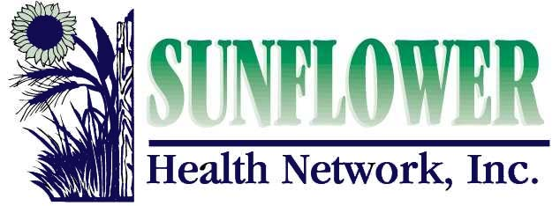

2024 SCHOLARSHIP APPLICATION FORM

Name:________________________________________________________________________

Address/City/Zip:_______________________________________________________________

Email Address:_______________________________ Phone Number:_____________________

Degree or Certification pursuing:________________________ School:________________________

The degree or certification is considered: Undergraduate Graduate

I have: Applied to the Program Been Accepted into the Program Not Applied to the Program

Current Employer (if employed) :___________________________________________________

Employer’s City/State:___________________________________________________________

Current Position:________________________________________________________________

Years in Current Position:_______________________ Years in Health Care Field:___________

Check List: Attach the following on individual pages, in the order listed:
1. Describe your health care career goals and why you would like to work in a rural community (Maximum of 250 words).
2. List of three (3) references with contact information.
3. Transcript(s) for completed credits from educational institutions (unofficial copy accepted). Include name and address of school as well as dates of attendance.
4. Resume including work experience and community service.

I certify that all information included in this application is true and accurate.

_____________________________________________________
Signature

Review: Applications are due March 1, 2024. Submit materials to: Heather Fuller, SHN, 400 S. Santa Fe, Salina, KS 67401 or hfuller@srhc.com. Electronic submission in 1 pdf document is preferred.

*For each year of scholarship, recipient agrees to commit to one year of service at a Sunflower Health Network member organization (if position is available).

